
NAME:_____________________ Class:______________ No.__________
- Circle and Write.
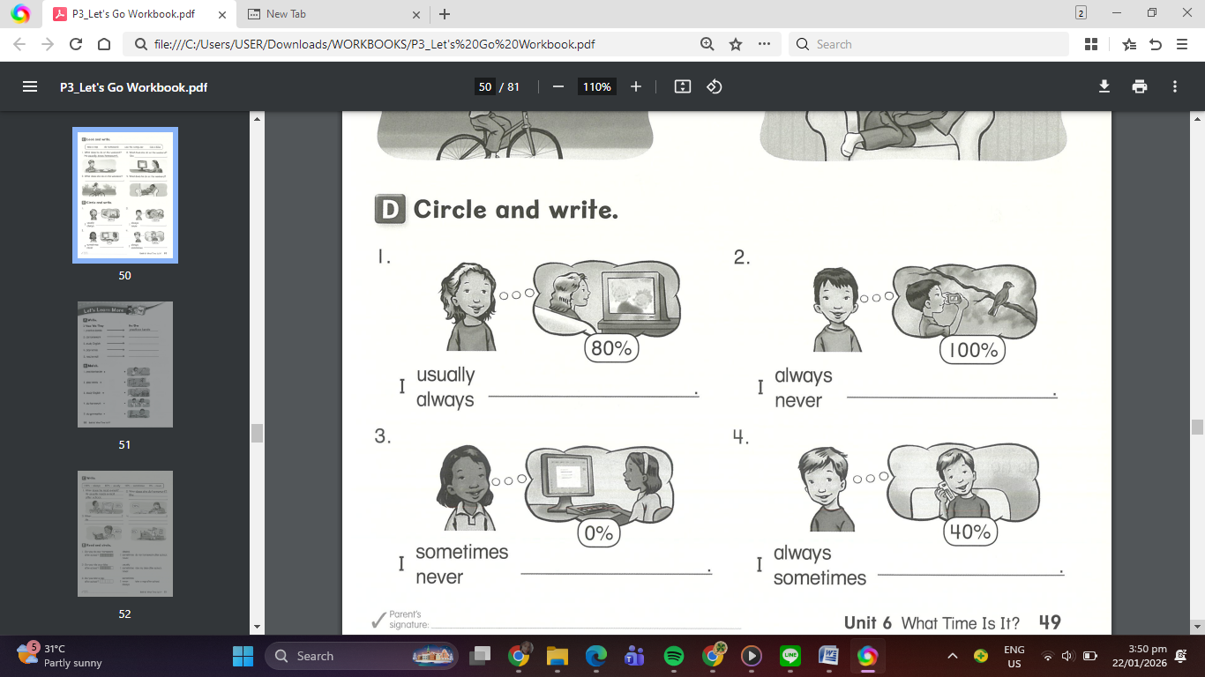
Circle the correct adverb of frequency, then write it correctly in the blank to complete the sentence.

- Write
Directions: Write the appropriate adverb in the blank.

