

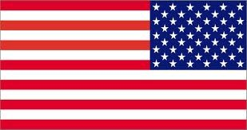
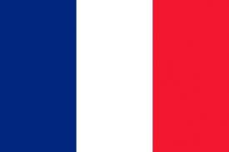
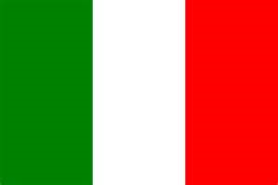
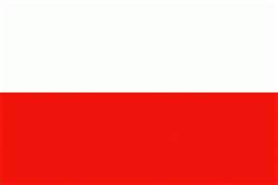
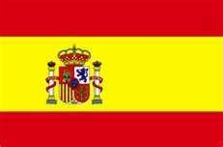
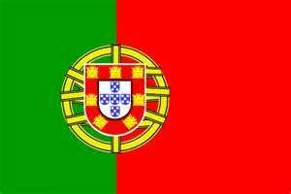
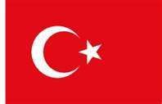
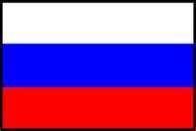
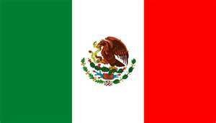

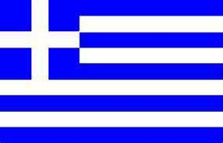
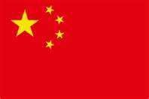







 |  | 
Vietnam | Vie_ _ _ _es_ | Vie_ _ _ _ es _
Italy | I t _ _ i a _ | I t _ _ i a _
Spain | S p _ _ i s _ | S _ _ n i _ _
England/ the UK | B _ _ t _ s _ | E n _ _ i s _
Mexico | M e _ _ c _ n | S p _ _ i _ _
Thailand | _ _ _ | _ _ _
Portugal | P _ _ _ u g _ _ _ | P o r t _ _ e s _
China | C h _ _ e _ e | C _ _ n e _ _
The USA | A m _ _ i _ a _ | E _ g l _ _ h
Turkey | T _ _ k _ s h | T u r _ _ s _
Russia | R u _ _ i a_ | R _ _ s _ a
Brazil | __________________ | P_ _tu_ _ _ s e
Poland | P o _ _ s h | P _ _ i _ _

